# 

# 

# 

# PATAN COLLEGE FOR PROFESSIONAL STUDIES

# Individual Reflective Report

# 

# 

# 

# Ujaalo Student Information Kiosk

# PROJECT REPORT

# Submitted by Submitted to

# Prabin Chapagain (1721484) UOB

**Individual Reflective Report**

This form is submitted by every member of your group and used to assess the level of teamwork in your group and the contribution of individuals. It may also form the basis of discussions which affect the grades received by individual group members.

|  |  |  |  |
| --- | --- | --- | --- |
| Student Number | First Name | Last Name | Group No |
| 1721484 | Prabin | Chapagain | 1 |

It was great opportunity for me to work in this assignment. As University of Bedfordshire assigned Student Information Kiosk in this semester. I was a great experience while working team members Kshitij Bajagain, Buddha Lama, Prajwol Thapa and Lokindra Dangi. As the work division mentioned below, I contributed according to task given to me. Proper co-ordination and equal contribution of all individuals in their respective sector during software development made this functional Ujaalo Student Information Kiosk.

**Work Division**

|  |  |  |  |
| --- | --- | --- | --- |
| **S. N.** | **Name** | **GUI &**  **Implementation** | **Diagrams &**  **Documentation** |
| 1 | Kshitij Bajagain | Student Dashboard , Events & Booking, My/All Booking , Account Details ,Clubs , Admin Dashboard design and their functionalities | ER Diagram, Class Diagram, Design and implementation, work division. |
| 2 | Lokendra Dangi | Add Events , Alter Events , Update Events, Delete Events design and their functionalities | UseCase Diagram, Class Diagram, Introduction of report, Testing part. |
| 3 | Buddha Lama | Register Page , Login Page , Why Us , Help, Brochure, Accommodation , User Information(admin) design and their functionalities | Sequence Diagram, Class Diagram. Project plan. |
| 4 | Prabin Chapagain | Browser Functionality , Campuses (Luton, Bedford, Aylesbury, Milton Keynes, Putter ridge , Patan College) ,Education Loan | Activity Diagram, Class Diagram, agile and primary research. |
| 5 | Prajwol Thapa | Splash Screen , Kiosk Main Home Courses(Undergraduate , graduate , Foundation and International Students) , Invoice Generation | Sequence Diagram, Class Diagram, aims and objectives and critical analysis. |

Evaluating team member’s work I have attested a table below which rates their work during project development.

|  |  |  |  |
| --- | --- | --- | --- |
| Student Number | First Name | Last Name | Contribution  (N,S,I) |
| 1723936 | Buddha | Lama | S |
| 1723333 | Kshitij | Bajagain | S |
| 1720849 | Lokendra | Dangi | S |
| 1721479 | Prajwol | Thapa | S |

**S** -Significant (The group member’s work was integral to the overall submission)

**N** -No Contribution (The group member took no part in the project submission)

**I** -Insignificant (The group member’s work made little difference to the overall submission)

At last, I would to thank everyone who have helped to complete this software. So , I am motivated and encouraged to complete upcoming assignments in future with more concentration and dedication.

**UML Diagrams:-**

1. **Activity Diagram :**

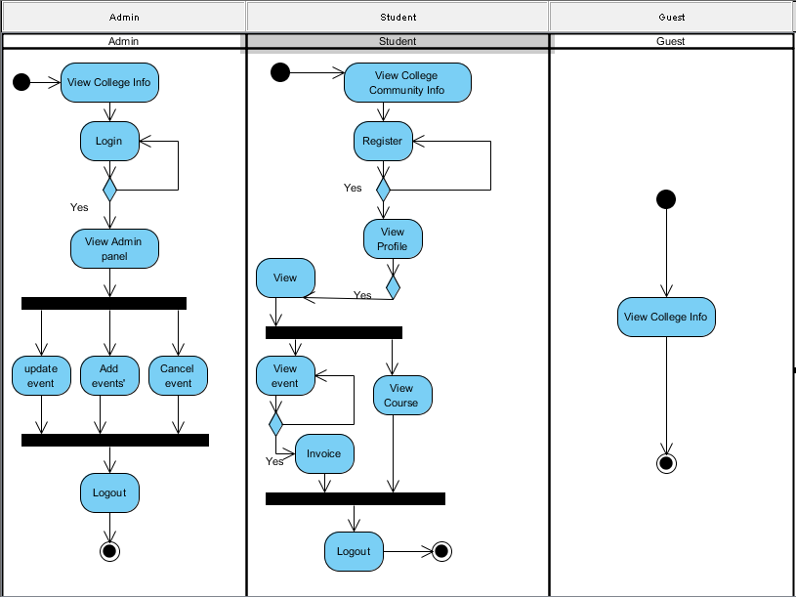

Fig: - Ujaalo Student Information Kiosk Activity Diagram

**GUI Screenshots of my part:-**

**1>Delete Events:**

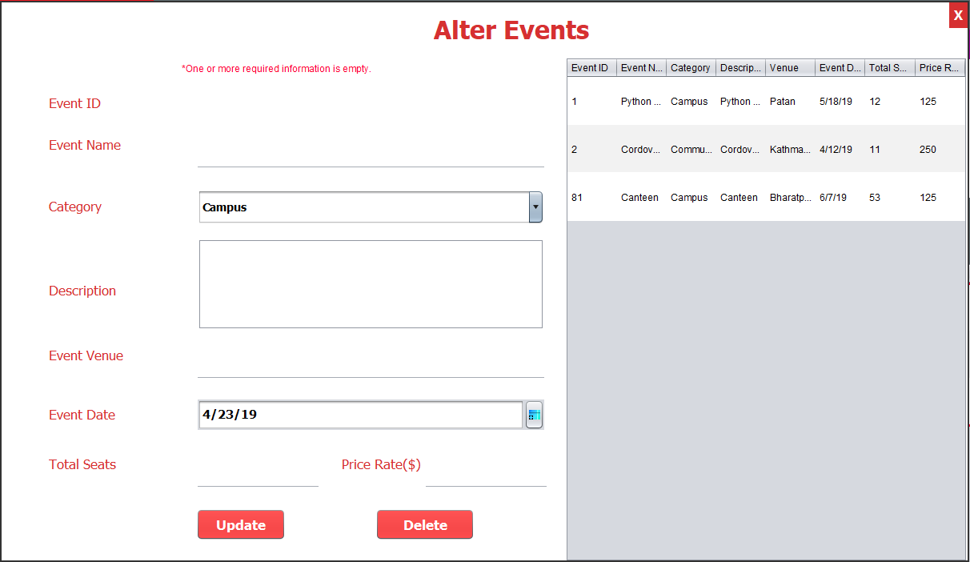

**2> Browser Functionalities:**

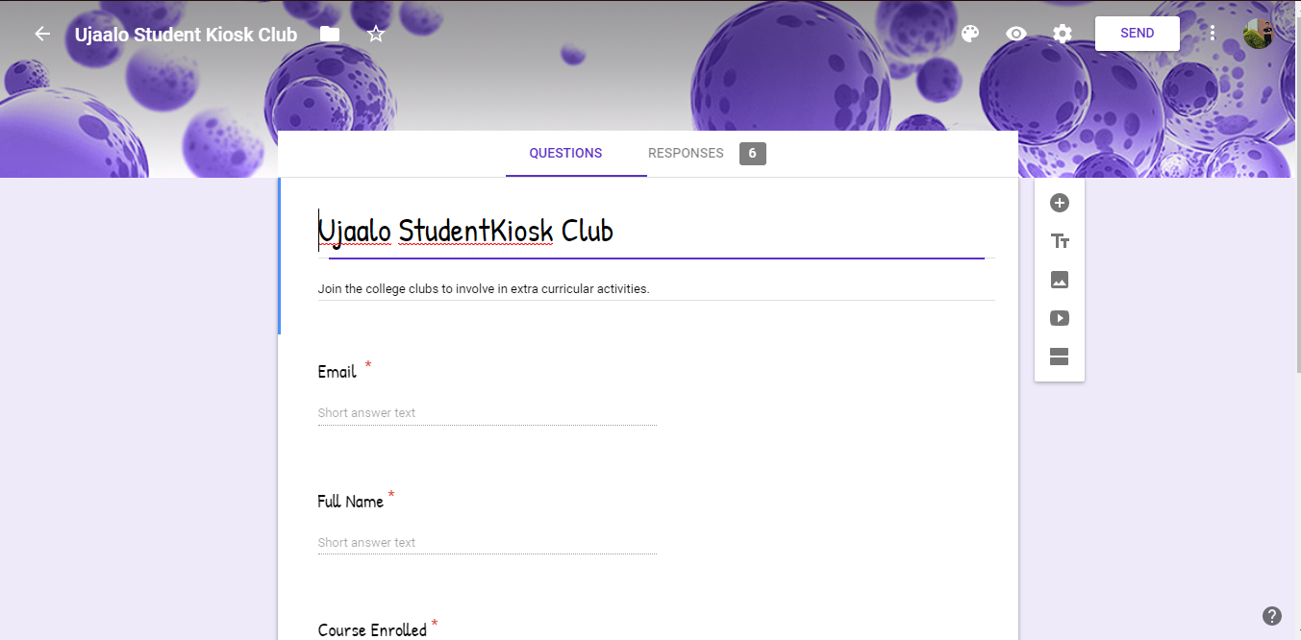

**3>**2>Campuses:

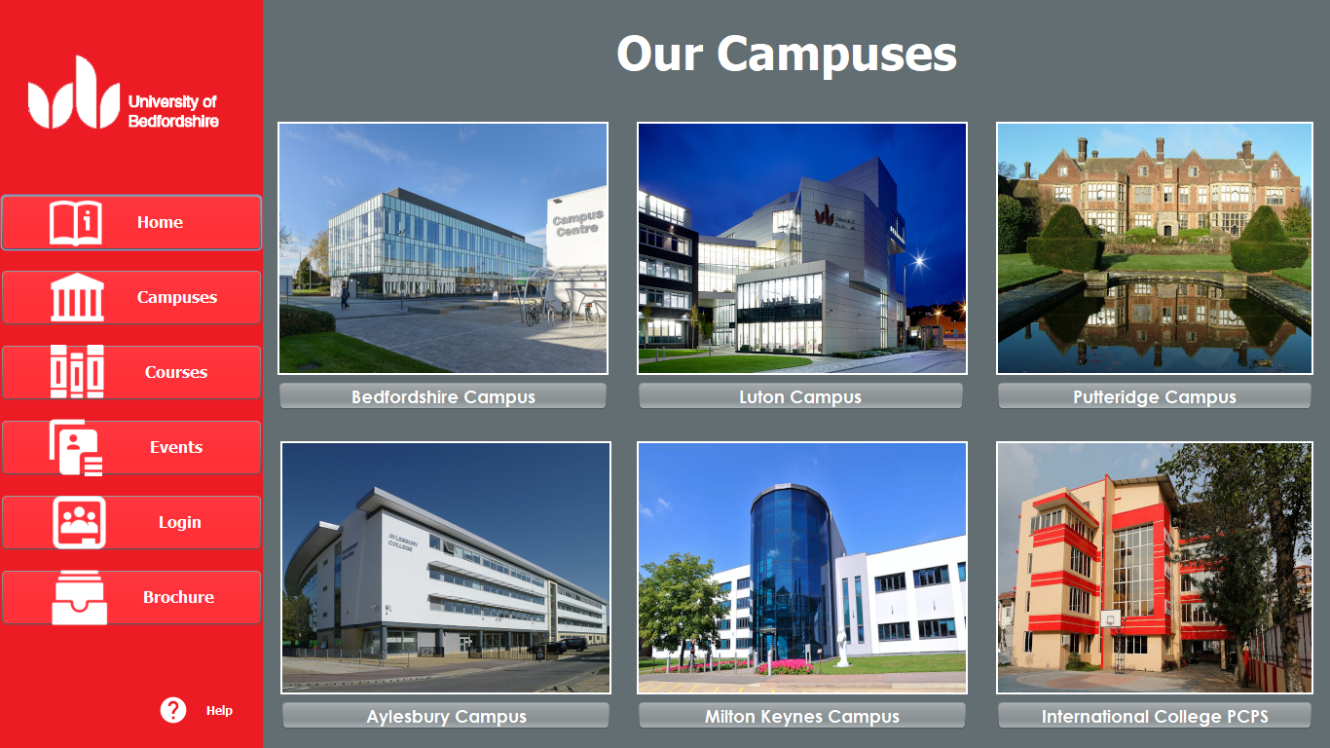

3>Campus About:

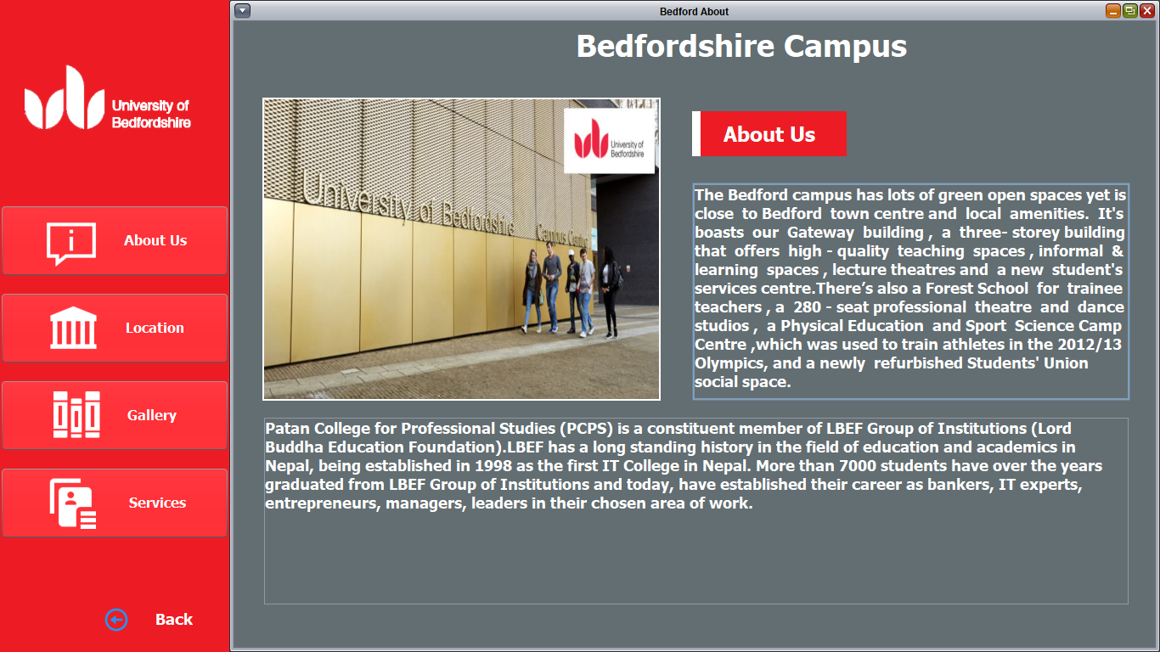

4>Campus Location:

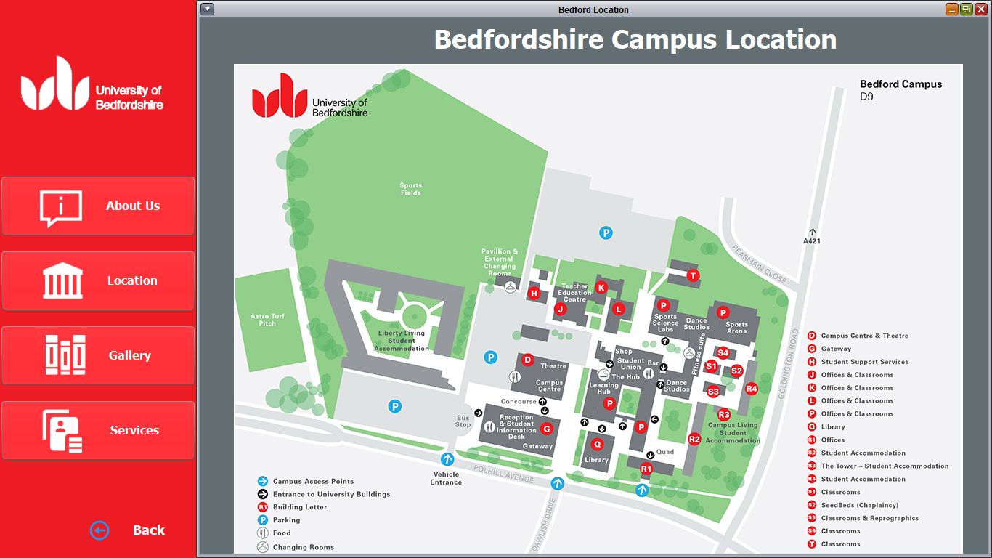

5> Campus Gallery:

